

King Fahd University of Petroleum and Minerals
Information and Computer Science Department

ICS 309
Term 201

A comprehensive comparison between Solar Winds, Suricata, And Darktrace IDS Softwares

Author: AMAAN IZHAR

Date: 9th Dec 2020

Introduction
Security has been a vital part to keep any company’s system and network administration safe from intrusions and attacks. If a system is targeted by a malicious hacker, it can result in significant loss of resources, data, and potential loss of customer trust, which can lead to company shutdowns due to business deprivation. However, to prevent such losses, technologists and engineers developed various types of intrusion detection systems (IDS) – which keep a system safe from various sorts of security breaches. Nonetheless, there is a variety of software that comes in the market for the stated purpose and it is often very difficult to pick up a good one. Therefore, this report aims to analyze, compare, and contrast between three commercial IDS softwares.

I. What Is IDS And Its Types?
The following sections will discuss the general definition of IDS and some notable differences from firewall along with a comprehensive description of its different types.
I.1 Definition of IDS
IDS – Intrusion Detection System is a computer coded software or electrically powered hardware that monitors the system and network resources and activities and alerts the network security officer when it detects any abnormal anomaly in the activity of a networked computer system/environment. Such activities result in a security breach of vital information and resources. IDS are based on two fundamental approaches – knowledge-based and behavior-based. On top of these approaches only, various other types of specific softwares are made. For example, anomaly-based detection is capable of responding to an intrusion behaviorally and it uses machine learning algorithms to achieve that.
A most common misconception is that IDS softwares are firewalls that act within the network. However, that is not true. There is a certain difference – i.e. firewalls limit access between networks to avoid intrusions whereas an IDS prevents as well as alarms the security personnel so that the person can take appropriate action. With that explained, let us move to IDS categories in the next section.

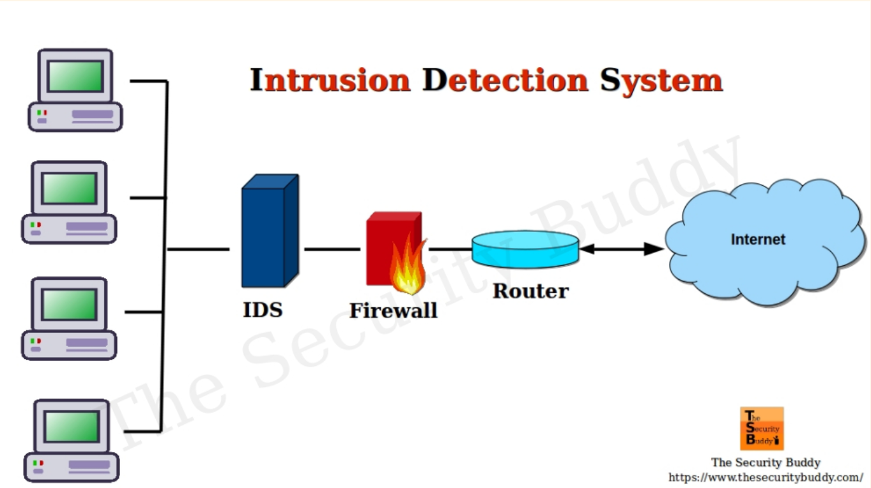
Figure 1. Working of an IDS along with a firewall.

I.2 Types of Intrusion Detection Systems
In a nutshell, there are 3 different types of intrusion detection systems – based on their workflow within the network. They are – in no particular order of their strengths and weaknesses:
- Network Intrusion Detection System (NIDS)
- Network Node Intrusion Detection System (NNIDS)
- Host Intrusion Detection System (HIDS)

Network Intrusion Detection System: In this type of IDS, it is installed and deployed at key strategic points in the entire network. Its main function is to cover the routes where traffic is most likely to be intercepted and is vulnerable to attack. They analyze large amounts of network packets traveling in and out of the system. The main advantage of NIDS is that attackers cannot detect whether it is installed or not as it is unassertive when working through the network traffic coming in the network on which it is deployed. This makes it secure and undetected.
Network Node Intrusion Detection System: NNIDS can be differentiated from NIDS with only one regard, i.e., it applies to one host at a time whereas NIDS is applied to a whole subnet. With this, every single host in the network can be monitored with the same strength as NIDSs. However, the downside is that it is used only when a single host is believed to be targeted the most. These types are not used much in the industry.
Host Intrusion Detection System: HIDS are installed and run on all the hosts and devices in the network as well as in other parts of the enterprise network. They weigh heavy on NIDS as they can peep deeper into the traffic and can act as a backup defense against vulnerable packets that NIDS fails to detect. It works by taking snapshots of the previous files and matches them with the current files and then drives out the differences between them. This way every packet and file is traced and malicious code is detected.

Hence, NIDS and HIDS are the most commonly used IDSs in the enterprise network. In the next topic, we will explore the three best softwares that achieve security in the best form for any networked environment.

II. The Three Alternatives – Description and Analysis
We will discuss and analyze three commercial IDS softwares that come in the market – Solar Winds Security Event Manager (HIDS+NIDS), Suricata (NIDS), and Darktrace (HIDS).
II.1 Solar Winds Event Manager
Solar Winds Event Manager is a HIDS software developed by Geekbuilt. Often called SEM – it is a lightweight, scalable, and affordable IDS software that monitors the network 24/7 in real-time and detects threats with the feature of combating any malicious attack on its own. It is mainly deployed on the windows server. Besides, it is capable of logging events and messages generated by various machines that include windows PCs, Mac PCs, Linux, and Unix PCs.
The primary function of SEM is that of a log manager. For example, it carefully examines all the connected devices on a network such as USB and file storage devices, hosts, etc., and checks the incoming and outgoing packets. Then, it checks for their integrity and modifications. If in any case, files are modified – this implies that there has been a breach and it notifies the system admin (if configured to manual mode). Moreover, SEM can also integrate with another secondary small-scale backed up software called Snort and can function as both HIDS and HIDS, thereby, increasing the security of a network by 10 folds. In addition to its primary function, some sub-functions of SEM can detect botnets. And for this, they do not require any custom scripts. It comes in the package itself.
A fascinating point to note is that this software comes in with 61 distinct features. Ranging from advanced pfSense firewall analyzer to Security automation. Some of the features are listed below:
- Database log audit tool
- DDoS prevention and mitigation tool
- Cyberthreat analysis tool
- Centralized log management
- Cross-site scripting prevention
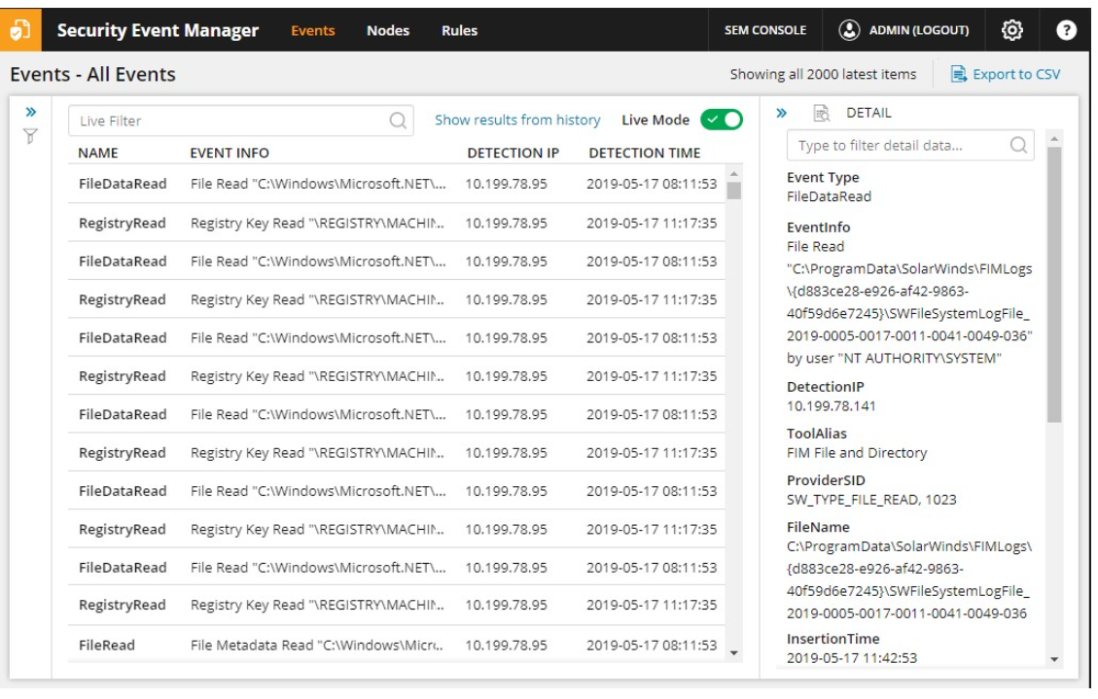
Figure 2. An example of an active logger in SEM.
Coming to the cost and pricing. SEM offers a 30-day free trial – after which it charges $499-$999 per month based on the features that you want to use. Therefore, SEM is a robust and comprehensive tool that can be used by any scaled enterprise.
Link to the software: https://www.solarwinds.com/security-event-manager

II.2 Suricata
Suricata is an open-source IDS and IPS software that was developed by Open Security Foundation (OISF) in 2009. It is a NIDS software that uses Lua scripting language to detect threats and intrusions. Furthermore, it is capable of detecting the kind of behavior that an intruder can render on a network. Its primary advantage is that one instance of Suricata can monitor multi-gigabit traffic without any system freezing. Moreover, it naturally detects protocols and conventions on any port and applies scripted detection logic to each packet for smoother service. Some of the functions that it provides are – logging HTTP requests, preventing flooding attacks, renders reports in JSON and YAML format (in case any other language wants to use it's API), and DNS logger.
Suricata not only acts as a NIDS but also as a NIPS engine. Its main advantage over other IDSs is that it can create alerts, filters, and apply rate limits. For example, whenever any attacker intrudes in a network, it will alert the entire system in addition to system admin and can freeze the incoming packets only to combat the attacker. Then it resumes the network after applying layer decoding for HTTP, SSL, TLS, etc. Furthermore, it applies a machine learning algorithm to detect the breach. The data it uses is its own logging data that is collected during its active course. Hence, it is a highly competent IDS software for enterprise networked environment.
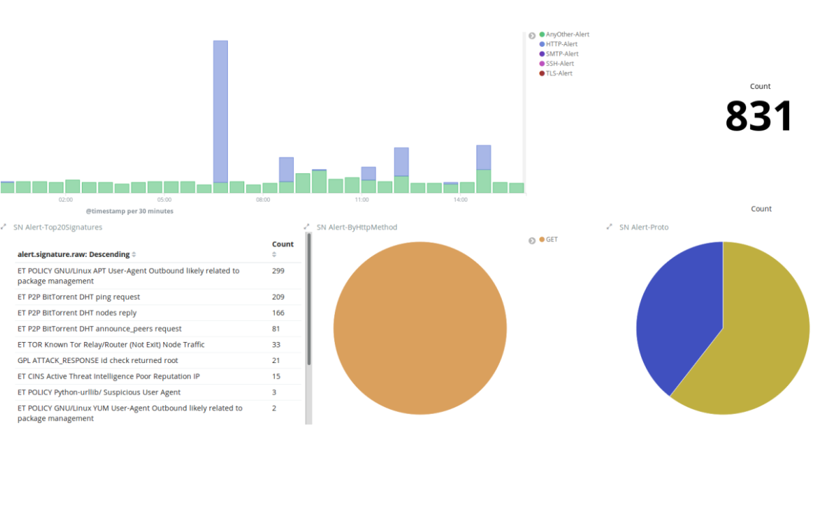
Figure 3. An example of an active logger in Suricata.

Now, coming to the pricing of the software. Suricata takes an edge over the other two software as it is free and open-source software. All you need to do is download the source code and follow installation instructions and rest aside your worries as it will handle the rest. Hence, Suricata is a good choice for startups as it deals with multi-threading support and is free for use.
Link to the software: https://suricata-ids.org/

II.3 Darktrace
Darktrace Enterprise Immune System is an AI/ML based self-learning IDS software system. Due to the implementation of ML algorithms, it can detect an intrusion at an early stage. It works as a HIDS. In comparison to Suricata, it continuously analyzes the network and learns from it, unlike Suricata which uses the data in time intervals. This software is intended to detect any malicious attack at an early stage through IoT hacks and latent vulnerabilities in the system.

One of the most talked-about features is called Threat Visualizer. It is a GUI desktop app that renders a 3-D view of all the threats to your company. It displays the threat level, where it is intended, where the system will alert, and to whom, etc. All in all, it gives a complete overview of the threat as well as its combating solution. The following image shows the GUI interface.
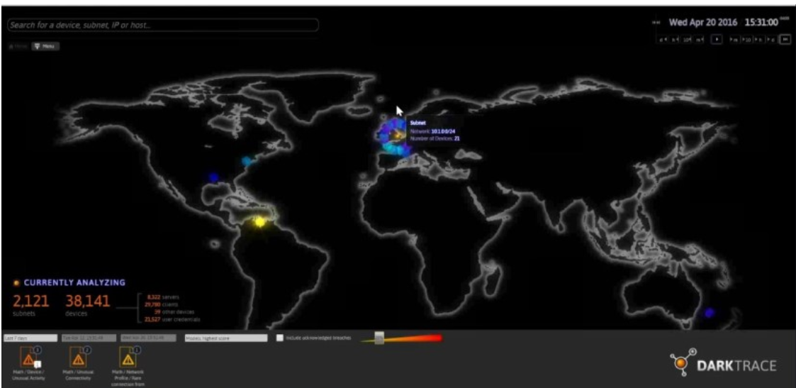
Figure 4. Threat Visualizer in Darktrace.
It is worthy to note that more than 4000 organizations rely on Darktrace. However, it does not include heavy features as the other two softwares discussed. Its primary highlight is that it is a lightweight software capable of detecting intrusions on a large scale. But even with these, it cannot match the features of SEM or Suricata. However, its pricing is somewhat acceptable, considering its features. It offers a 30-day free trial and then charges $10000 for the full purchase of the system.
Therefore, Darktrace is suited for startups as well as medium scaled enterprises. However, it is not worth a very large-scale company like Google, Microsoft, etc.
Link to the software: https://www.darktrace.com/en/
III. Tabular Comparison
Having compared the three softwares, we will summarize their strengths and weaknesses in a tabular format for a robust and rich reference.
Software | Manufacturer | Supported Type | Features | Pricing | Best For | Company Usage
Solar Winds Event Manager (SEM) | Geekbuilt | HIDS + NIDS (Use case with Snort) | 61 distinct features.  Best feature – Log monitoring with an auto-response mechanism. | 30-day free trial. Subscription-based ($499-$999 per mo.) | Large Scale, medium-scale, and startup enterprise. | Microsoft, Linux, Cisco, Palo Alto, Sophos.
Suricata | Open Security Foundation (OISF) | HIDS  (Large scale) | High performance, protocol detection, and packet decoding. | Free and open source. | Large scale and startups. | Microsoft  and various startups like Intellias.
Darktrace | Cambridge University machine learning specialists and GCHQ | HIDS  (Medium scale) | Threat Visualizer and AI-powered defense mechanism. | Charges $10000 for the whole package. | Medium-scale enterprises and startups. | eBay, Premier Oil, Micron, Jimmy Choo.

Hence, we compared the three softwares in terms of their manufacturer, features (strengths), pricing, type of IDS, best fit for, and company usage.

IV. Which IDS should MLify use and why?
MLify (MY FUTURE COMPANY) - is an auto-machine-learning company that operates in the Kingdom and USA and its primary objective is to serve/render automated ML services to millions of ML enthusiasts, researchers, and companies. Since the service it provides is aimed at a larger network of entities and the company holds various types of data, it is highly possible that its network could be intruded on by attackers. Therefore, if we discuss about the type, it should opt for a NIDS to monitor each node within its network. And this can be achieved by using Solar Winds event management software that additionally can be combined with Snort to work as a HIDS+NIDS. With SEM installed, we would not have to worry about our data breach from any connected node and can easily backtrack the logs and improve our security in weak nodes (if any). Furthermore, its cost is also affordable on this scale as it is subscription-based. Therefore, the company would not face any problem in terms of installation and price.
Therefore, if MLify wanted to use one for its network, then clearly, SEM is the best choice. Furthermore, scaling it to a larger network as well as to its sub-groups will be flexible with SEM.

Conclusion
In conclusion, IDSs have become a fundamental requirement to protect a networked environment in any organization. Three commercial softwares were discussed briefly, giving all the necessary details, and analyzed in this report. A unique way of using IDSs would be to combine different types and integrate them into one. Based on this approach, the most effective IDS software turned out to be SEM which can work as both NIDS and HIDS. In addition to my future company, this tool can also be used by various universities for their networks and sub-groups to achieve better data and network security.

References:
- What Is an Intrusion Detection System? Definition, Types, and Tools. (2020, October 12). Retrieved November 26, 2020, from https://www.dnsstuff.com/intrusion-detection-system

- Security event manager. (2019, November 18). Retrieved November 27, 2020, from https://en.wikipedia.org/wiki/Security_event_manager

- Suricata (software). (2020, November 10). Retrieved November 27, 2020, from https://en.wikipedia.org/wiki/Suricata_(software)

- DarkTrace. (2020, November 10). Retrieved November 28, 2020, from https://www.darktrace.com/en/

- IDS Image. (2020, November 12). Retrieved November 28, 2020, from https://www.thesecuritybuddy.com/data-breaches-prevention/what-is-ids-intrusion-detection-system-how-does-it-work/

